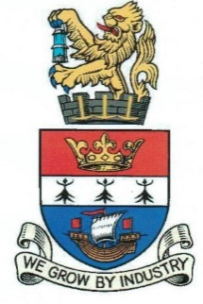

BLYTH TOWN COUNCIL

To: ALL MEMBERS OF EVENTS COMMITTEE

You are hereby requested to attend a meeting of BLYTH TOWN COUNCIL EVENTS COMMITTEE to be held in the Council Chamber at Arms Evertyne House on Tuesday 26 July 2016 at 6.30pm.

The Agenda for the meeting is set out below.

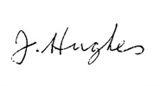
JOE HUGHES
ACTING TOWN CLERK
BLYTH TOWN COUNCIL 19 July 2016

Would you please ensure that all mobile phones are switched off during the meeting

NB: The meeting is open to all Town Councillors and Members of the Public

AGENDA:

1 | APOLOGIES FOR ABSENCE
2 | DISCLOSURE OF INTERESTS AND GRANT OF DISPENSATIONS
3 | MINUTES OF THE EXTRAORDINARY EVENTS COMMITTEE MEETING HELD ON 5 JULY 2016
4 | MATTERS ARISING
5 | NORTHUMBERLAND LIVE MUSIC FESTIVAL  Mel Jackson in attendance to feedback from 2016 event and submit proposals for the 2017 event.
6 | BUDGET AND EVENTS FOR 2016/2017 (reports will be displayed on the board during the meeting)  - Introduction of Online Ticket Sales for the Fireworks Event (please see letter from Bruce Emmett, We Scan Tickets, attached)
7 | TALL SHIPS EVENT UPDATE
8 | BLYTH TOWN FAIR  Tony Ellis and Jonathan Hogg in attendance to feedback from the event.  Written report from the Events Co-ordinator to follow.
9 | NORTHUMBRIA IN BLOOM  Verbal update from Office Manager.
10 | ITEMS FOR INFORMATION AND URGENT BUSINESS
11 | DATE & TIME OF NEXT MEETING  Tuesday 27 September 2016, 6.30 pm in the Council Chamber, Arms Evertyne House.

Councillors: K Nisbet (Chair) A Cartie (Vice-Chair)
C Bruce A Gibbs-Barton
M Parker J R Potts
R Parker L Rickerby
A Turnbull

Copy to all other Town Councillors for information

