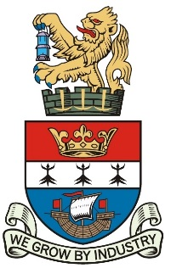

BLYTH TOWN COUNCIL

To: ALL MEMBERS OF THE EVENTS COMMITTEE

You are hereby requested to attend a meeting of BLYTH TOWN COUNCIL’S EVENTS COMMITTEE which is to meet on Tuesday 24 January 2017 in the Council Chamber, Arms Evertyne House, Quay Road, Blyth, NE24 2AS at 6.30 pm.

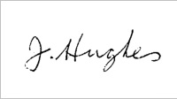
The Agenda for the meeting is set out below.

Joe Hughes
Town Clerk
BLYTH TOWN COUNCIL 14 February 2017
Electronic devices can be used to access Committee papers. Please ensure that mobile phones are switched to silent mode during the meeting.

AGENDA
1 | APOLOGIES FOR ABSENCE
2 | DISCLOSURES OF INTERESTS AND ANY GRANTS OF DISPENSATION
3 | MINUTES FROM THE EVENTS COMMITTEE HELD ON TUESDAY 24 JANUARY 2017
3.1 | MATTERS ARISING
4 | BLYTH CARNIVAL CLUB PROJECT & FILM FROM TALL SHIPS (10 minutes)  Allie Walton-Robson in attendance to present a short film of the Tall Ships Regatta Community Parade and update of the plans for the Blyth Community Carnival.
5 | UPDATE FROM EVENTS ORGANISER  Please see attached report.
6 | CHRISTMAS LIGHTS UPDATE  Verbal update will be provided.
7 | ANY OTHER BUSINESS OR ITEMS FOR URGENT ATTENTION  This item is only for items of information to be given to Town Councillors  and for items which either the Committee Chair or Town Clerk consider  to be genuinely urgent.
8 | DATE AND TIME OF NEXT MEETING  Tuesday 28 March 2017, 6.30 pm in the Council Chamber, Arms Evertyne House.
9 | PART II  An Event in Blyth  Pursuant to the Public Bodies (Admission to Meetings) Act 1960; that in view of the confidential nature of the business about to be transacted, it is advisable in the public interest that the press and public be excluded and they are instructed to withdraw.

MEMBERS OF THE EVENTS COMMITTEE:

Councillors: K Nisbet (Chair) A Cartie (Vice-Chair)
C Bruce A Gibbs-Barton
M Parker R Parker
J R Potts L Rickerby
A Turnbull

Officers: J Hughes, Town Clerk
A McCabe, Officer Manager
S Robinson, Environmental Services Officer
M Hawthorne, Committee Clerk

