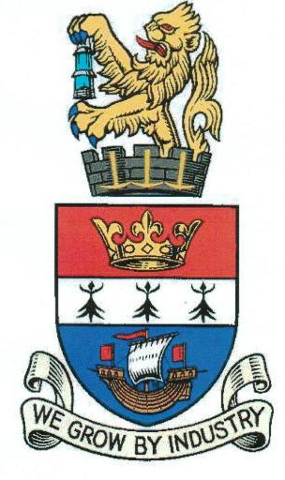

BLYTH TOWN COUNCIL

To: ALL MEMBERS OF THE EVENTS COMMITTEE

You are hereby summoned to attend a meeting of BLYTH TOWN COUNCIL EVENTS COMMITTEE to be held in the Council Chamber, Arms Evertyne House, Quay Road, Blyth, NE24 2AS on Tuesday 30th September 2014.

The Agenda for the meeting is set out below.
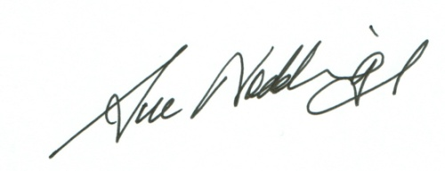

SUE NODDINGS
TOWN CLERK
BLYTH TOWN COUNCIL 23rd September 2014
Would you please ensure that all mobile phones are switched off during the meeting

AGENDA:

- APOLOGIES FOR ABSENCE

- DISCLOSURE OF INTERESTS AND ANY GRANTS OF DISPENSATION

- MINUTES FROM EVENTS COMMITTEE MEETING HELD ON TUESDAY 2nd SEPTEMBER 2014

4. UPDATE REGARDING FORTHCOMING BLYTH TOWN COUNCIL EVENTS

Report from the Events Co-ordinator attached

4.1 Fireworks Festival
4.2 Christmas Activities and Events
5. ANY OTHER BUSINESS OR ITEMS FOR URGENT ATTENTION

This item is only for items of information to be given to town councillors and for items which either the Committee Chair or Town Clerk consider to be genuinely urgent.
It can be used to raise issues for discussion at the next meeting. Town Council law means there should be no substantive discussion of an item which is not on the agenda.

6. DATE OF NEXT MEETING

The next Meeting of the Events Committee scheduled to take place on the 25th November 2014 at 6.30pm.

MEMBERS OF THE EVENTS COMMITTEE:

Councillors: - C Bruce
A Cartie (Vice Chair)
A Gibbs-Barton
K Nisbet (Chair)
M Parker
J R Potts
L Rickerby
G Thompson
A Turnbull

Officers: S Noddings Town Clerk (Corporate Services)
S Robinson Assets Officer
A McCabe Office Manager

PLUS INVITED PARTICIPANTS:

Paul Taylor – Events Co-ordinator (Contractor)
Michael Nicholson – National Market Traders Federation
Steve Bucknall – Northumberland County Council
Steven Bradley and/or another representative of Blyth Town Team
Representative from Friends of Ridley Park
Representative from the Port of Blyth
Representative from Northumbria Police
Representative from BVAL
Representative from Aspire2Achieve
Representative from Headway Arts
Representative from BAIT
Representative from Royal Northumberland Yacht Club

