BLYTH TOWN COUNCIL

To: ALL MEMBERS OF BLYTH TOWN COUNCIL

You are hereby requested to attend a Meeting of BLYTH TOWN COUNCIL to be held in the Council Chamber, Arms Evertyne House, Quay Road, Blyth, NE24 2AS on Thursday 16th January 2014 at 6.30pm.

The Agenda for the meeting is set out below
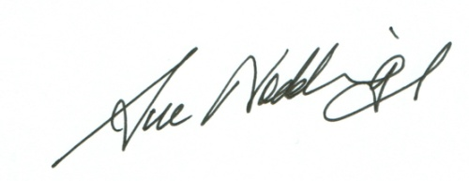

SUE NODDINGS
TOWN CLERK
BLYTH TOWN COUNCIL 7th January 2014
Would you please ensure that all mobile phones are switched off during the Meeting.

AGENDA:

1. APOLOGIES FOR ABSENCE

2. PUBLIC QUESTION TIME

3. MINUTES OF THE PREVIOUS MEETINGS

3.1 To agree the Minutes of the Meeting held on the 14th
November 2013.

4. MINUTES OF THE ALLOTMENTS COMMITTEE

To adopt the Minutes of the Meeting held on 17th December 2013.

5. MINUTES OF THE ASSETS COMMITTEE

To adopt the Minutes of the Assets Committee held on the 10th December 2013.

6. MINUTES OF THE EVENTS COMMITTEE

To adopt the Minutes of the Events Committees held on the 26th
November.

7. MINUTES OF THE FINANCE COMMITTEE

To adopt the Minutes of the Finance Committee held on 9th
January 2014.

8. MINUTES OF THE PLANNING AND DEVELOPMENT COMMITTEE

8.1 To adopt the Minutes of the Planning and Development Committees held on 28th November and the extraordinary Meeting held on the 11th December 2013.

8.2 To consider any urgent planning related issues.

9. MINUTES OF THE STAFF COMMITTEE

No Meeting of the Staff Committee has taken place since the last meeting of the Full Council.

10. MINUTES OF THE POLICY WORKING GROUP

10.1 To adopt the Minutes of the Policy Working Group held on 21st November 2013.

11. MINUTES OF THE COMMUNITY GRANTS COMMITTEE

No Meeting of the Community Grants Committee has taken place since the last meeting of the Full Council.

12. ANY FURTHER INFORMATION AND ITEMS FOR URGENT ATTENTION

13. DATE OF THE NEXT MEETING OF THE FULL COUNCIL

The next meeting of the Full Council is scheduled for Thursday 20th March 2014.

MEMBERS OF THE COUNCIL:

Councillors: - R Parker (Mayor)
M Parker (Deputy Mayor)
C Bruce
A Cartie
B W Elliott
K Ellis
A Gibbs-Barton
G T Knox
K Nisbet
J R Potts
O Potts
J Reid
L Rickerby
D Rutter
G Thompson
A Turnbull

Officers: S Noddings Town Clerk (Corporate Services)
S Rickitt Town Clerk (Democratic Services)
S Robinson Assets Officer
A McCabe Office Manager
L Forsyth Committee Clerk

