BLYTH TOWN COUNCIL
Minutes of the Assets Committee held in the Council Chamber at Arms Evertyne House on Thursday 4th June 2015 at 6.30 pm.
Present:
Councillors: J R Potts (Chair), O Potts (Vice Chair), B W Elliott and J Reid
Non Committee Members: None
Officers:
Town Clerk (Corporate Services) – Sue Noddings
Assets Officer – Sean Robinson
Committees and Communications Officer – Liam Forsyth

Members of Public: None.
108/15/01: APOLOGIES FOR ABSENCE
Apologies for absence were received from Councillors A Cartie, K Ellis, L Rickerby and D Rutter.
109/15/02: DISCLOSURE OF INTERESTS AND GRANT OF DISPENSATIONS
Councillor J Reid declared an interest as a Northumberland County Councillor and as holding a seat of the Board of Directors at ARCH.
110/15/03: MINUTES OF THE ASSETS COMMITTEE HELD ON THE 7TH APRIL 2015
The Town Clerk (Corporate Services) wished to comment that she had not, as of the time of the Meeting, received the up to date figures for insuring play areas from Came and Co. She did, however, comment that as soon as they were received they would be circulated via the Chair and Vice-Chair.

The Minutes of the Assets Committee held on the 7th April 2015 were AGREED by the Committee and signed by the Chair.
111/15/04: ASSETS OFFICER’S REPORT
(Please see attached reports)
With regard to the litter bins, the Committee AGREED to note the installations previously agreed which are contained within the report, as well as the bins within the additional report.
Councillor B W Elliott enquired regarding placing bins on lamp posts due to a concern from a resident on Plessey Road. The Assets Officer provided an outline of the situation noting that we are unable to put bins on the lamp posts, and that we are currently replacing lamp post mounted bins with ground mounted bins where applicable.
Discussion was then held as to the associated costs for purchasing and installing of litter bins. It was noted that the installation was covered by the Partnership Agreement.
The Committee AGREED to purchase 20 ground mounted bins in order to replenish stocks.
The Assets Officer raised concern regarding the time for installation of Assets within the Town. It was commented that in order to ensure this issue is addressed it is to be raised at the next meeting of the Partnership Board.
Discussion was then held as to vandalism within the Play Areas. The Chair, Councillor J R Potts, commented that it is important to log and monitor vandalism in order to note any recurring issues arising.
Councillor J R Potts enquired as to whether the damage repairs were part of the Partnership Agreement. The Town Clerk (Corporate Services) commented that temporary repairs and quick fixes were part of the Partnership Agreement.
Councillors J R Potts enquired as to the trees at Axwell Drive. The Assets Officer commented that only one tree is remaining and that discussions have taken place with Northumberland County Council with regard to replacing with more mature trees.

The Assets Officer then initiated discussion regarding changes to Section 106 monies and the current situation within Northumberland.
Following the discussion regarding Section 106 monies. The Assets Officer recommended that the previously agreed refurbishment at Burns Avenue proceed with funding to be sought from this Committee, Section 106 monies and via Awards for All. This was AGREED by the Committee.
It was also AGREED to continue to seek costed plans for a park at Newsham Farm Estate.
The Assets Officer confirmed that the ‘stickering’ of the Assets had now been completed and that we have received communication regarding damage to the bins arising from the completion of this process.
Discussion was then held regarding advertising in bus shelters. It was noted that conversations were on going in order to ascertain the bus shelters they would be interested in and the associated costs.
Councillor B W Elliott requested a bus shelter on Wensleydale Terrace following a request from a local resident.
It was AGREED that this was to be investigated in co-ordination with Northumberland County Council and the adjacent shop keeper.
Councillor J R Potts commented on the affect of the new development on Laverock Hall Road and the need for new bus stops on this road. This is to continue to be investigated.
With regard to seating, it was AGREED that the seat at Mulberry Play Area is to remain due to popularity so the previously agreed seat closer to the South Beach Pub is to be drawn from stock.
Discussion was then held as to War Memorials.
It was AGREED that a future meeting of the War Memorials Sub Committee is to be arranged and discussions are to take place regarding taking ownership of the associated land beside the War Memorials.
Councillor J R Potts wished to thank the Assets Officer for his thorough report.
112/15/05: BLYTH PARTNERSHIP UPDATE
(See attached dashboard)

The Town Clerk (Corporate Services) provided an outline for the partnership dashboard which is also available via the Blyth Town Council website.
Discussion was held as to the need to monitor the weeds within the Town as complaints have been received.
The Assets Officer wished to encourage Councillors and members of the public to come forward in order to ensure the issues are addressed.
The Town Clerk (Corporate Services) then went on to initiate discussion regarding the finances of Blyth Partnership. It was noted that Northumberland County Council are still not able to provide the monthly financial reports as contained within the agreement.
Discussion was then held as to the secondment of the Senior Team Leader to other areas of South East Northumberland without formal consultation. It was noted that this is to be raised at the next meeting of the Partnership Board. Action: SR
Discussion was also held as to the need to plan for Bank Holiday weekends in order to ensure that the bins are not overflowing over such a period.
113/15/06: ANY OTHER BUSINESS AND ITEMS FOR URGENT ATTENTION
None.
114/15/07: DATE OF NEXT MEETING
It was AGREED that the next meeting of the Assets Committee is to be held on Thursday 30th July 2015 at 6.30 pm in the Council Chamber.
MEMBERS OF THE ASSETS COMMITTEE:
Cllr J R Potts (Chair)
Cllr O Potts (Vice-Chair)
Cllr A Cartie
Cllr B W Elliott
Cllr K Ellis
Cllr J Reid
Cllr L Rickerby
Cllr D Rutter
Cllr A Turnbull

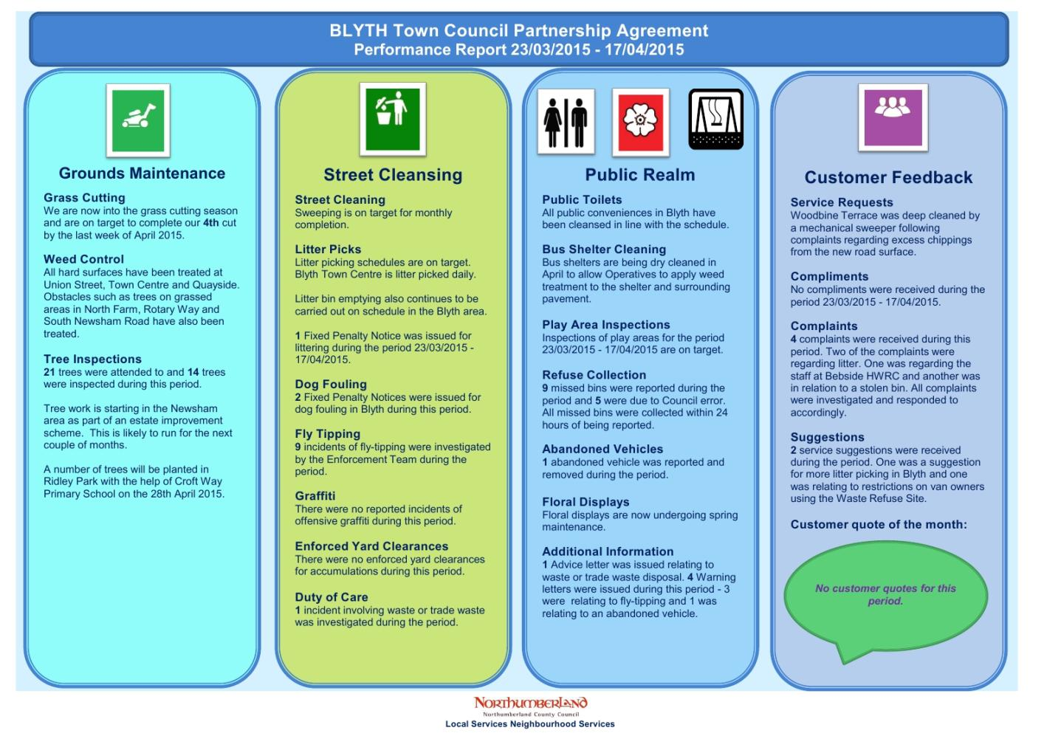

BLYTH TOWN COUNCIL
Assets Committee
04 Jun 2015

Report of the Assets Officer

Litter Bins

The following ground mounted & post mounted litter bins have been installed by the Partnership team.

Location | Bin Type | Date installed
Rear of Woodlands Park | GMPB | 01.04.15
Rear of Tern Close | GMPB | 01.04.15
South Beach Playing | GMPB | 14.04.15

The following litter bins are due to be installed:

Location | Bin Type | Quantity
Duridge Drive adjacent bus shelter at entrance to estate | GMPB | 1
Duridge Drive adjacent to seat at entrance to estate | GMPB | 1
Rothbury Avenue at entrance of each cut leading to the Isabella | GMPB | 2
Quayside between existing litter bins on Commissioner’s Quay | GMPB | 1
Durban Street | GMPB | 2
Mulberry Close Play Area | GMPB | 2
Park Road/Beaconsfield Street | PMLB | 1
Links Road adjacent to Trident Drive | GMPB | 1

A request from Councillor Deidre Campbell (NCC) with regards to feedback from the Newsham Residents Association meeting, they have requested a litter bin to be installed near to the play area at Cottingwood Green. I have contacted the Partnership team who empty the litter bins and they have informed me that the bins that are already in the play area are sufficient. However, if the funding is granted for the new MUGA and Parkour we will install extra litter bins once the MUGA and Parkour are built.
The current stock levels of both post mounted and ground mounted litter bins:
PMLB: 15
GMLB: 30
These totals do not include the above litter bins to be installed therefore I would like to request to purchase a further 20 GMPB to maintain an adequate stock.
Recommendation: To purchase 20 x GMPB.
A request has been made to install 7 litter bins in Ridley Park. I have passed this request to NCC (Active Northumberland) as they are responsible for the park. For information NCC are installing 2 GMPB and 5 temporary litter bins. The 2 GMPB will be taking from our stock and will be invoiced at cost price.
All information stickers are in the process of been placed on all litter bins and will be completed by 22 May 15.
Play Areas

Weekly inspections have been carried out by NCC through the BTC/NCC Partnership agreement. Please find below the following defects:

Play Area | Date Reported | Damage | Obtain quote Y/N | Cost
Cowpen | 27.04.15 | Access gate loose | Y
 | 27.04.15 | Fire damage to rubber matting | Y
 | 27.04.15 | Lamp post loose adjacent to teen shelter | Passed to NCC Street Lighting team
 | 05.05.15 | Fitness equipment damaged | Y | Temporary repair
Axwell Drive | 20.04.15 | Litter/Glass cleared | N/A | No cost
 | 27.04.15 | Edge blocks missing | N/A | No cost
 | 27.04.15 | Basket swing vandalised | Y | £40
Ogle Drive | 20.04.15 | Soft Pour surfacing vandalised | Y | £40
Millfield Gardens | 21.04.15 | Slide area – surfacing – edges shrunk | Y
Broadway | 28.04.15 | Spinning Rocker bearing worn out | Y
Mulberry Close | 11.05.15 | Side panels on slide vandalised | N/A | Covered by SLA
 | 25.05.15 | Fence panels kicked out | N/A | No cost

Mulberry Close:

The installation of the play area has now been completed. The post installation handover meeting was conducted on 11 May 15 and BTC now retain the responsibility of the play area. There has been minor vandalism of the slide and the fence with fence been repaired 27 May 15. Two litter bins are to be installed and the partnership team will be increasing the frequency of emptying the litter bins over the coming weeks. The play area is proving to be very popular and it is extremely busy especially over the weekends. It was recommended that the seat outside the play area that was to be removed and placed further along the path towards the South Beach pub is to remain in situ. My recommendation is to install an additional seat from stock on the path leading to the pub.
The grassed entrance to the play area has been worn away due to the volume of traffic and to ease access for pushchairs I recommend that a path be installed. I have received one quote and awaiting a further two quotes for the work to be carried out.

Axwell Drive:

There have been three further incidents of vandalism at the play area. Bricks have been removed surrounding the slide. Out of the nine trees that were planted only one tree now remains. The basket swing was damaged with the bolts been removed. The basket swing was removed for safety reasons and the bolts have been replaced with the swing now back in action. The landscaping surrounding the play area has now been seeded and the grass is now growing in.

Cottingwood Green:

From the last Assets Committee meeting that it was agreed to proceed with the planned installation of the MUGA and Parkour equipment. The application to the S106 Housing Development Fund has been submitted along with a pre-application planning request to the NCC Planning Department and also a licence request for the land. The S106 Funding Board sits on the 9th June 2015 with results of the application released on the 26th June 2015.

Burns Avenue Play Area:

With the agreement to go ahead with the refurbishment of the play area I have had an initial pre-design planning meeting with Paul Taylor (KOMPAN). As part of the service level agreement KOMPAN will be conducting a consultation process. A public meeting (location TBC) will be held to listen to residents requirements. A questionnaire is to be completed at the meeting and also hosted online, for those that cannot attend. We will utilise our own website and social media platforms to advertise this event. Flyers will also be produced and posted to the residents. A design will then be produced following the consultation to fully represent the needs of the Council and surrounding community. An update will follow once more information is received.

Newsham Farm Estate:

The initial pre-design meeting has been held with Paul Taylor (KOMPAN) and the Head/Deputy Head Teacher of Newsham Primary Academy with regards to the installation of a new play area at the entrance of Newsham Farm Estate. As with Burns Avenue the same procedure will be applied to the proposed new play area at Newsham Farm Estate and updates will follow once further information is obtained.

Bus Shelters

Please see below the following bus shelters that were damaged and now have been rectified:

Unique ID Number | Location | Damage | Cost
BS030 | Amersham Road, adjacent junction Dunblane Drive | Missing seat | £150 + vat
BS031 | Amersham Road, adjacent junction Bromley Gardens | Missing seat | £150 + vat
BS057 | Briardale Road, adjacent Cowpen Shops | Missing front Perspex panel | £100 + vat
BS054 | Tynedale Drive, adjacent junction Ferndale Close | Missing side Perspex panel | £100 + vat
BS039 | Cowpen Road, adjacent Cowley Road | Broken side panel | £100 + vat

The following bus shelters have been damaged and are awaiting quotes for the repair costs:

Unique ID Number | Location | Damage | Cost
BS070 | Plessey Road, adjacent to Patterson House | Missing side panel
BS011 | Cowpen Road, opposite ASDA, near Lonsdale Ave | Broken Side panel

Cleaning:

All bus shelters have been cleaned in April and May in accordance with the BTC/NCC Partnership agreement. All information stickers have been attached to all bus shelters with exception of the brick built bus shelters. An alternate solution is to be sought for these bus shelters.

Advertising:

A meeting was held (18 May 15) with O2 Blyth with regards to the possibility of advertising to be placed in a number of bus shelters in the town. I was informed by the branch manager that they are speaking to their Head Office to ascertain a budget for this project. An update will follow when more information becomes available.

There is a request from Cllr Elliot that a request for a bus shelter to be installed on Wensleydale Terrace adjacent to the convenience store.

Seating

The cleaning of the seats has now commenced in accordance with the BTC/NCC Partnership agreement. All of the wooden slats in the seats will be treated and wood stain applied over the coming months. The seats will also be re-painted as and when required.

War Memorials

The War Memorial sub-committee needs to meet to move this project forward. A suitable date will be promulgated in due course.

The area surrounding the Cowpen War Memorial is in need of an upgrade. I will meet with J Reith (NCC) on completion of the Northumbria in Bloom completion to formulate some ideas and costs.

Toilets

I am awaiting the delivery of the toughened glass to replace the windows that were damaged. They will be fitted in due course.

AOB

The play area signs have now been manufactured and delivered and will be fitted week commencing 01 Jun 15.

Sean Robinson
Assets Officer

04 Jun 15

BLYTH TOWN COUNCIL
Assets Committee
04 Jun 15

Additional Report of the Assets Officer

Please find below amendments and additional information to the Asset Officer’s Report for the Assets Committee meeting to be held on 04 Jun 15.

Litter Bins

Further request for litter bins to be installed/replaced have been received:

Location | Bin Type | Quantity
Adjacent to the bus shelter at Albion Way/ Ingram Drive | GMPB | 1
Adjacent to the bus shelter at Waterloo Road/junction Cypress Gardens | PMLB | 1
Park View | GMLB | 1

There has also been a request from Homes for Northumberland that further litter bins be installed in the new development at South Newsham Road. There is a meeting arranged (05 Jun 15) to see where the litter bins are to be installed and how many they require.

Play Areas

With regards to the proposed installation of a MUGA and Parkour I have been contacted by the Leisure Strategy and Development team at Active Northumberland stating that there are insufficient funds to support the bid. This is due to the change in the collection of S106 monies and the introduction of the new Community Infrastructure Levy during 2015/16. They have pointed out that there is only a HDF balance for Blyth Play of £14,317.96 available in this fund and as from previous meetings the Assets Committee stated that installing new play areas would only go ahead if there was 100% funding available.

This will also have an impact on the proposed installation of the play area at the entrance to Newsham Farm Estate where the same problem as above will occur.

As agreed from the last Assets Committee meeting that it was agreed that Burns Avenue play area would be the next in line for refurbishment using this financial year’s budget (Play Area Renewal Code 770) I would like to bid for the remainder of the s106 monies to support the refurbishment of Burns Avenue. I am also researching other avenues of funding through Awards for All to supplement the proposal.

Recommendation: To prioritise the refurbishment of Burns Avenue Play Area and to bid for the remainder of the S106 Monies in order to supplement the funding of the project.

To put on hold both the installations of the MUGA/Parkour at Cottingwood Green and the play area at Newsham Farm Estate until more details of the Community Infrastructure Levy are known.

Bus Shelters

Please see below the following bus shelters that have been damaged:

Unique ID Number | Location | Damage | Cost
BS034 | Cowpen Road, adjacent to the Dales School | Missing back panel
BS035 | Cowpen Road, adjacent to Maple Cresent | Missing back panel
BS052 | Albion Way, near junction Ingram Drive | Missing side panel
BS056 | Tynedale Drive, adjacent to junction Weardale Avenue | Missing side panel

Quote and costs have been requested.

Sean Robinson
Assets Officer
04 Jun 15

