Review of the Year 2017

Introduction
- I have been in post as the Town Clerk of Blyth Council for over 12 months after taking up my position in November 2016. A review of the achievements of the past year is due to acquaint members of the main issues that have arisen in a busy year for the staff and yourselves.

- My appointment arose because of the former Town Clerk leaving to take up a new appointment. An approach that I have used in my career has been to build up confidence of the members and staff in my organisational abilities, experience of complex situations and problem-solving capability as well as encouraging open and transparent teamwork. The first three skills are a matter for my annual appraisal and have been discussed with the Chair and Vice Chair of Staff Committee and the consultant appointed to assist in the process.

- The teamwork aspect of the organisation is a more difficult matter and requires building trust with the staff and encouraging the exchange of ideas. It also includes having confidence that the staff views and problems are properly brought to the attention of members. A great number of the achievements that this review mentions are down to team effort. My stance is that every member of staff is an important part of the team and any congratulations on a job well done should be shared accordingly although there are times when an individual has made a major contribution to the success of a project. It should be remembered however that the individual needs support of other staff to achieve their major contribution.

- I am extremely pleased with how the staff have responded over the past year and the last few months when we have had a reduced workforce. They are working more effectively as a unit and seem happy with their working environment and how they are treated. I must thank them for their effort to support my philosophy and the help the Deputy Clerk has given in building the morale of the office.

- I have picked out below some of the milestones during the last 12 months which taken together amount to some of the achievements the council members and staff can be proud of and proving that teamwork and hard work bring rewards.

Blue Plaque Scheme

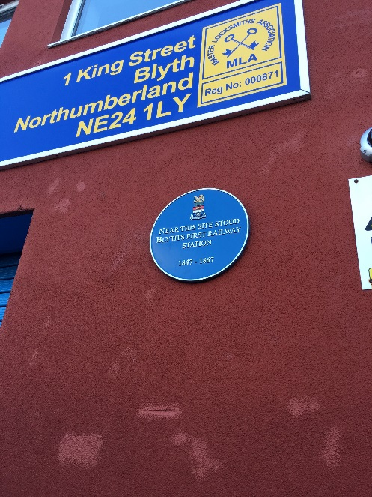
The above scheme has been started and many plaques have now been installed on various buildings. These plaques give an indication to the townspeople of the rich history of Blyth by picking out notable people and buildings. They also can help the Council by encouraging people visiting the area to get a feeling for the town past and present. The development of the scheme has given staff the opportunity to gather research and knowledge of the town and helps us to understand the proud association with the sea and other heavy industry. I would like to thank the Committee Clerk for taking the opportunity to make such a success of the scheme.

Warwickshire Regiment Commemoration Service

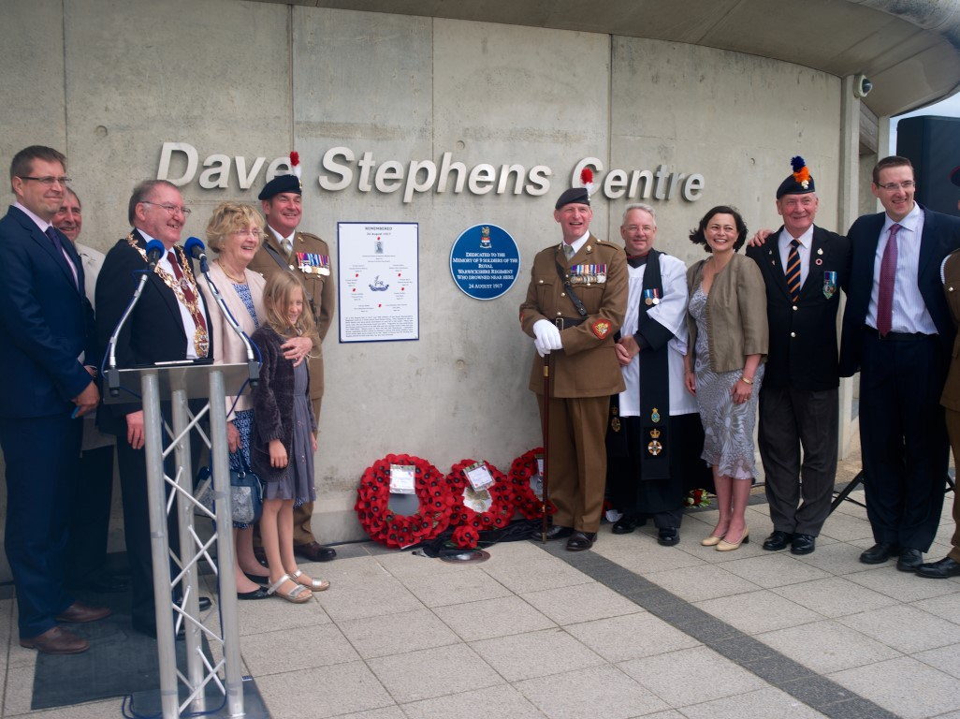
In August 2017 a service was held at the Dave Stephen's Centre to commemorate the centenary of a tragedy that occurred when 9 young men of the Royal Warwickshire Regiment drowned at the beach. The Council liaised with Blyth Battery, the Armed Forces and Fr Swinhoe at Horton Parish Church to organise the event. Particular thanks go to the Events Coordinator and Office Manager for bringing this event together. A letter of thanks was sent to the Mayor from Colonel Carruthers, OBE TD, of the Royal Regiment of Fusiliers for an outstanding event. He also stated that it was possibly one of the best that he'd ever attended.

The first blue plaque in the scheme was unveiled as part of the service and an information board installed at the carpet flower bed which had been planted to commemorate the tragedy.

War Memorials

This is a major piece of work that the council has agreed is a high priority for 2018 because of the centenary commemoration of the end of World War I. A tremendous amount of effort has been put in by the team and they have received support from members and Major D Fairbairn who represents the Elswick (Blyth) All Arms Association.

Work will be carried out on all three war memorials with extensive work being done on the Ridley Park structure and surrounds. I feel the work when it is finished will be appreciated by the public and something that we can be proud to have been associated with.

Events

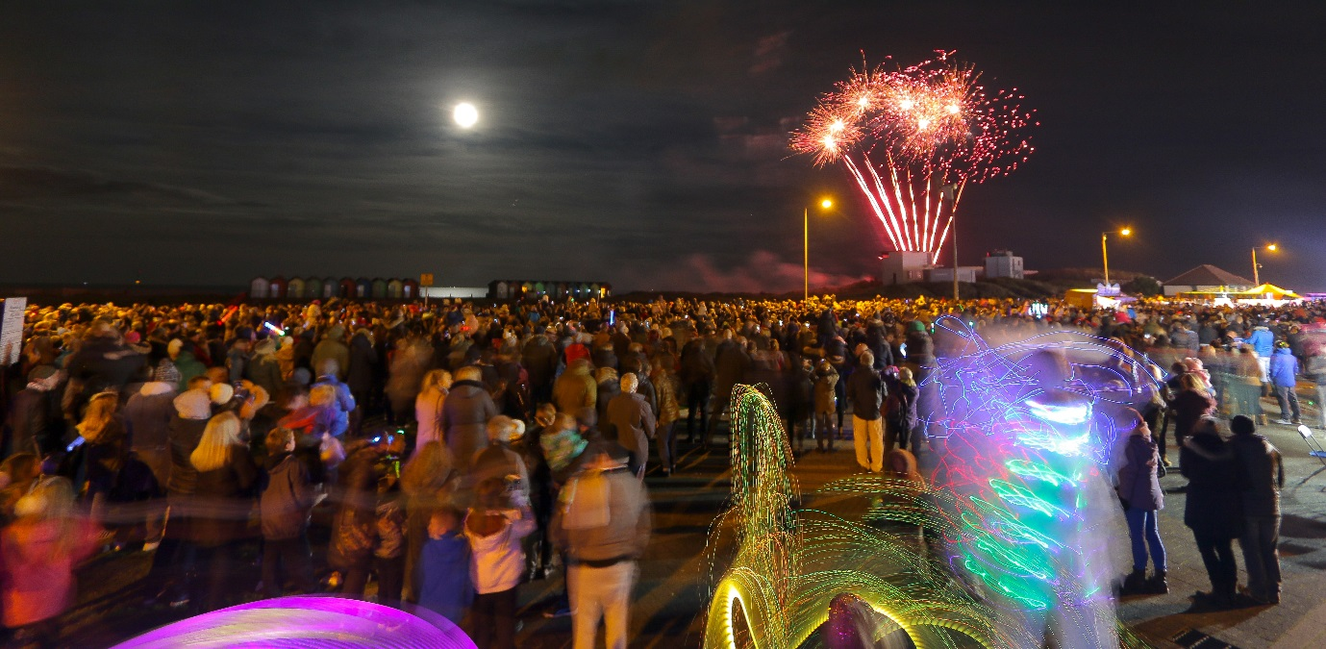
Many successful events have taken place in the last year or so that have been well attended and drawn in people from the surrounding areas. In particular Northumberland Live and the Fireworks Display were very well attended, and a review of the Display was carried out which gave us some useful points to improve our future performance. The Events Coordinator has proved in her first year of the contract to be an asset to the Council and has worked well with the staff to deliver the programme of events. Currently a cultural strategy is being worked on to present to the Committee for consideration.

Audit

An important aspect of good governance is the independent check of the accounting statements and to demonstrate a sound system of internal control. During previous years the external auditor has commented on issues that need attention. I am pleased to say that for year ended March 2017 a clean audit report was received which is a testament to the improvement in financial administration and the transparent nature of the records kept by staff as well as the monitoring arrangements of the Finance Committee.

Allotments

The last twelve months have been a testing time for the Allotments Committee and the Allotments Officer due to the issuing of the new tenancy agreement and related issues. The move to the new arrangements went very smoothly. However, difficulties arose during the year in relation to one allotment which resulted in the end of a tenancy after work had been carried out by the council in relation to the water supply had been tampered with. On a happier note the work in relation to dividing the original allotment, which was big in relation to the standard size, has produced 5 additional plots available.

Governance

The Council resolved in the second half of 2017 to review their procedures in relation how they demonstrated good and transparent governance. They recognise it is extremely important to show the townspeople that public money has been spent wisely and proper check and balances have been in place. This review involved a working party, assisted by a consultant, who spent many weeks coming up with a suitable model to recommend to Council for approval. The new system of governance will operate from May 2018 and it is the intention that a more joined up approach to decision making will be an outcome.

New Councillors Handbook

A new council was elected in May 2017 and a number of Councillors had no experience previously of serving on Blyth Town Council. It was felt that developing a member’s handbook would be helpful both to new members and re-elected ones. I am grateful that members felt it was very useful and contained a lot of helpful information. Thanks, in particular to the Committee Clerk for the research and work done to complete the handbook on time.

Christmas Lights

The Christmas lights display has become an annual event that is welcomed by the townspeople and it helps to engender the festive spirit in the town and hopefully attract people to the shops. The work involved building up to the display should not be under estimated. Each position needs to be identified and the particular light identified to match up with that position. This is essential to ensure that the installation of the lights by the contractor is as the council envisaged. The Office manager plays a major part in this planning of the display and the production of light column layouts matched to the motif. The Town Council and I are very grateful for the work carried in relation to the successful display.

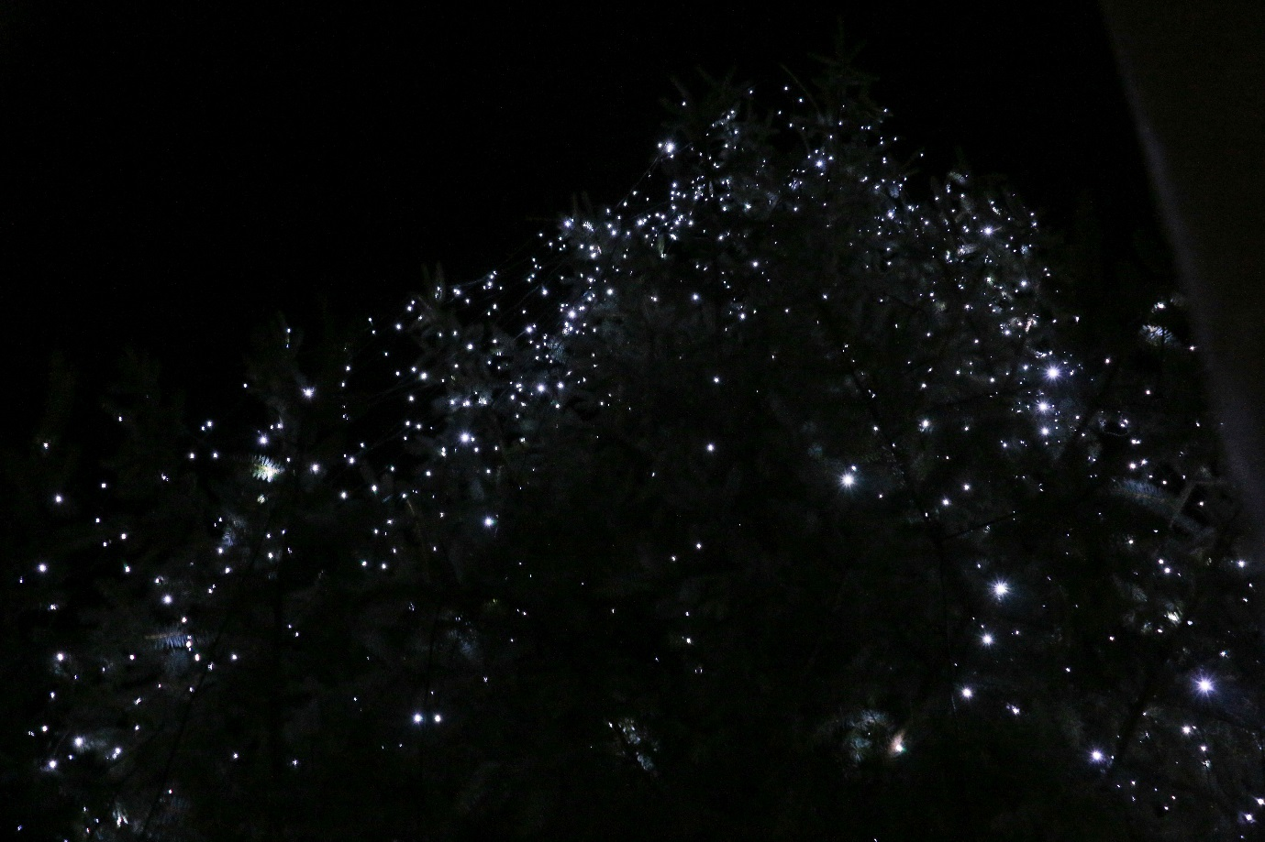

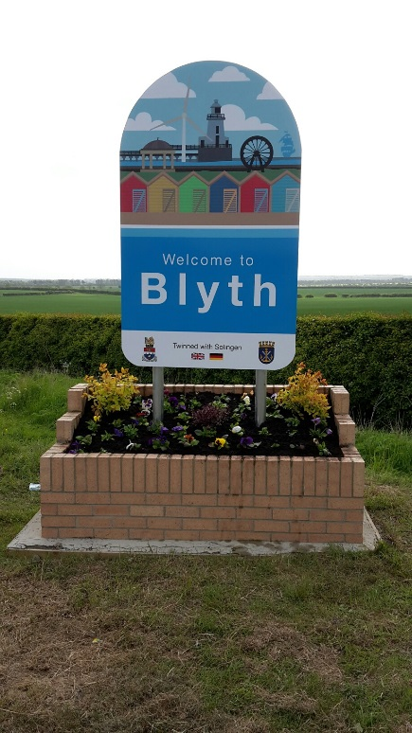

Gateway Signs

The Council agreed a design for new gateway signs to be installed on the boundaries of the Town. The signs depict some of the landmarks and heritage of the town and have been well received.

Cycling Murals

The Tour of Britain mural that was formerly shown on the demolished toilet block at Broadway has been replaced with a mural commemorating the two Tour of Britain races that have come through Blyth. Seating and planters have also been included leaving an area where townspeople can sit and enjoy the surroundings.

Staff Induction Pack

A staff induction pack has been produced that gives staff details that they will find useful.

Blyth in Bloom

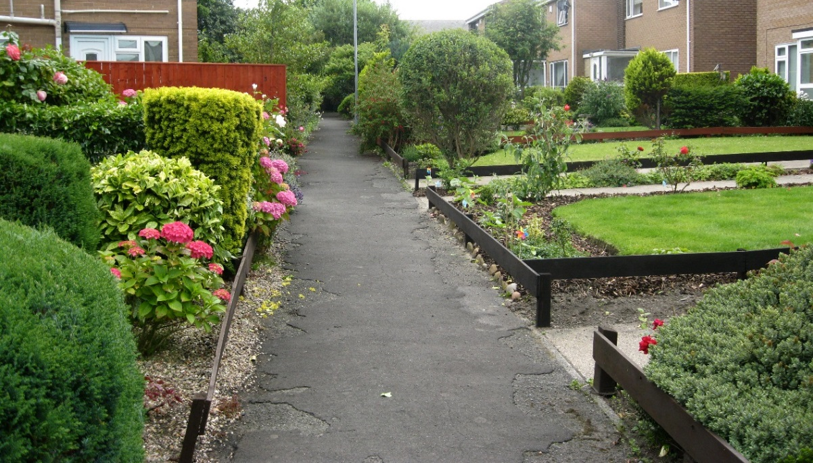
Blyth in Bloom was organised this year and it proved a great success, and everyone was pleased with the event. It is hoped to build on this event in future years. Many thanks to the Office Manager for her work in making the event such a success.
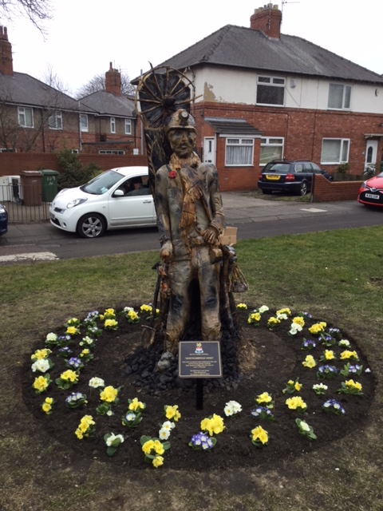
Tree Sculpture

The Council agreed that a sculpture could be carried out on a tree on the corner of Cowpen Road and Hodgsons Road.
A sculptor from Seaton Sluice, Tom Newstead, was given the work of carving a miner into the trunk of the tree and work is complete. This has generated much interest by those passing the site and a lot of compliments have been passed to Tom.

Enforcement Officer

The Council took a major step forward in combatting anti-social behaviour in the town when they agreed to devote extra resources to help with this issue. The objective of keeping the town clean and projecting an image of tidiness is a of great importance to the town councillors.

