BLYTH TOWN COUNCIL
Surplus Equipment

Blyth Town Council have a number of pieces of equipment which are now surplus to requirements. The Finance Committee agreed that these should be offered to local charities or community groups that may be able to make use of them. It was suggested that the fairest way to do this would be by means of a draw for each separate piece of equipment. If you are interested in any of the following items please contact us by

30 November 2016

The draw will be made at the

Events Committee meeting on 13 December 2016

and the successful applicant will be contacted by email. Items will need to be collected from Arms Evertyne House and no warranties/guarantees, electrical or otherwise, are given by the Town Council.

Contact us

Email: info@blythtowncouncil.org.uk
Tel: 01670 361668
Post: Blyth Town Council
Arms Evertyne House
Quay Road
Blyth
NE24 2AS

Surplus Equipment

- Laptop/Projector Stand (x1)
- 40” (1016mm) Toshiba TV with Stand (x1)
- Electronic Raising/Lowering Projector Screen (x1)
- Projector (x1)

Laptop/Projector Stand

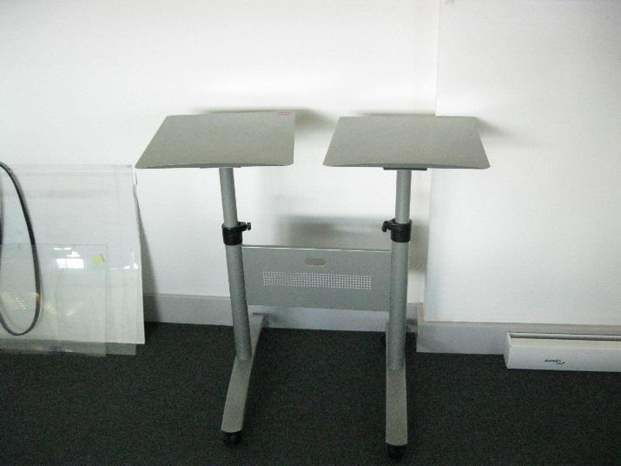

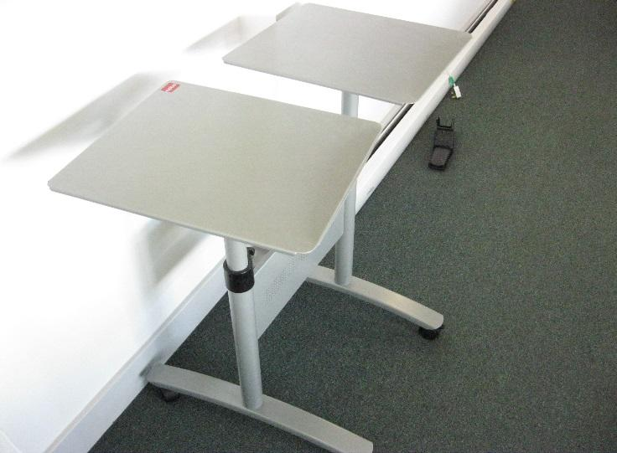

40” (1016mm) Toshiba TV with Stand
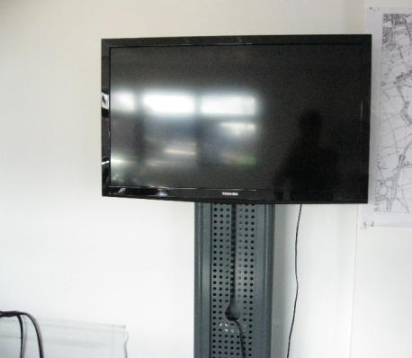
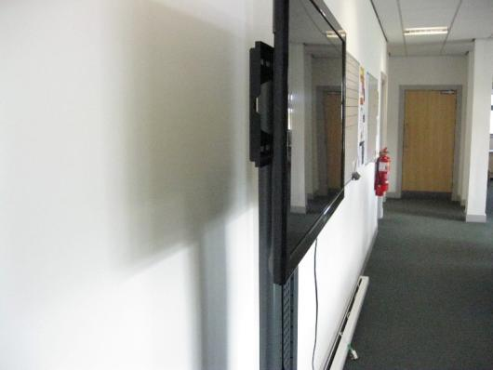

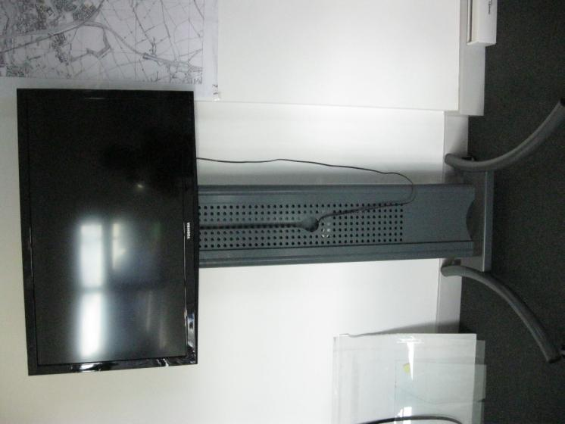

Electronic Raising/Lowering Projector Screen
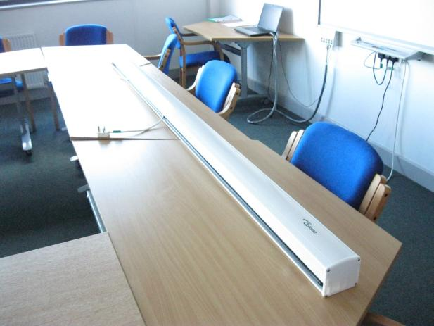

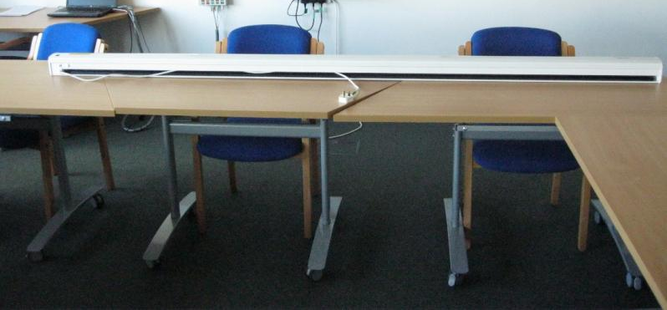

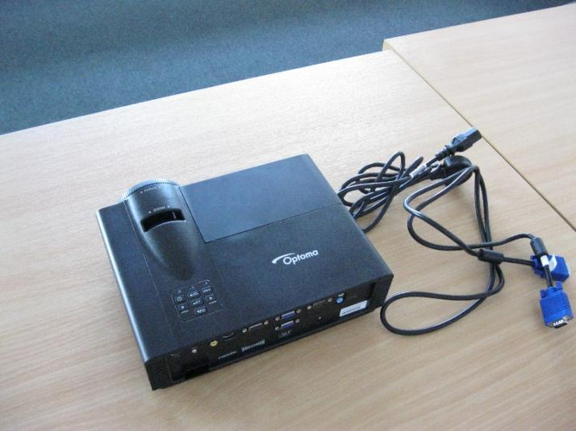
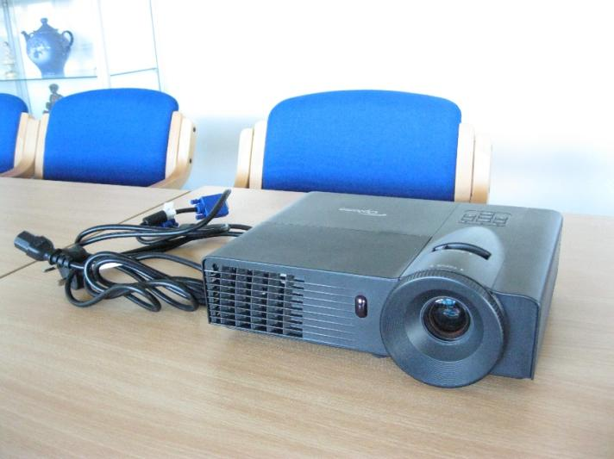
Projector

