BLYTH TOWN COUNCIL

TO: ALL MEMBERS OF FINANCE COMMITTEE

You are hereby requested to attend a meeting of BLYTH TOWN COUNCIL FINANCE COMMITTEE to be held at Arms Evertyne House, Quay Road Blyth, NE24 2AS, on Tuesday 6th May 2014 at 6.30pm.

The Agenda for this meeting is set out below.
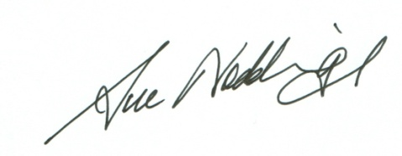

Sue Noddings
Town Clerk (Corporate Services)
Blyth Town Council 29th April 2014

Would you please ensure that all mobile phones are switched off

AGENDA:

- APOLOGIES FOR ABSENCE

- DISCLOSURE OF INTERESTS AND GRANT OF DISPENSATIONS

3. MINUTES OF THE FINANCE COMMITTEE HELD ON THURSDAY 13th
MARCH 2014

4. UPDATE ON THE FINANCIAL REPORTS: -

4.1 Discussion regarding future arrangements and requirements
4.2 Update on the Investment Accounts and Future Investments
4.3 End of Year Accounts
4.4 Update on Management Control Reports
4.5 Budgetary Update and Revisions
4.6 Arrangements for Precept
4.7 Excel Training for Councillors

5. PARTNERSHIP WORKING (UPDATE)

6. ITEMS FOR INFORMATION AND URGENT MATTERS

This item is only for items of information to be given to town councillors and for items which either the Committee Chair or Town Clerk consider to genuinely urgent.

7. DATE OF NEXT MEETING

The next meeting of the Finance Committee is currently scheduled for Thursday 3rd July 2014 at 6.30pm in the Council Chamber.

MEMBERS OF THE FINANCE COMMITTEE:

Councillor K Ellis (Chair)
Councillor J R Potts (Vice-Chair)
Councillor B W Elliott
Councillor A Gibbs-Barton
Councillor G T Knox
Councillor K Nisbet
Councillor O Potts
Councillor J Reid

Copy to all remaining Town Councillors for information

