Friday Funnies 16th Oct
My wife thought I was joking when I said I had bought a spaghetti car
You should have seen her face when I drove Pasta.

Man and woman travelling on the train
Woman: Every time you smile, I feel I want to invite you back to my place.
Man: Wow are you single
Woman: No I’m a dentist

I remember when I could refer to my knees as left and right now it’s the good one and the bad one.

Books didn’t make it.
Running to the outhouse
By Willy Makit
Illustrated by
Betty Wont.

Couple having a romantic dinner
Woman: Name a book that you Cry
Man: Algebra for the modern world

Let us Remember.
“Our world is not divided by Race, Colour, Gender or Religion. Our world is divided by wise people and fools. It is the fools that divide themselves by race, colour, gender or religion.”
Mohamad Safa

Nurse: Doc, there’s a man in the waiting room says he is invisible
Doc: Tell him I can’t see him today

Mick: I’m reading a book on gravity
Bob: is it any good
Mick: I can’t put it down.
Riddles
1. What is that, which breaks but doesn’t fall and that which falls and cannot break?
2. You have a single match and are in a pitch black room with a candle, an oil lamp, and a gas stove. Which do you light first?
3. Could you list numbers which have letter A in their spelling from
1-100?
4. If you jump off the roof of a three-story building, where would you land?
5. If a Monkey, bird and squirrel race up a coconut tree. Which one of them is most likely to reach the banana?

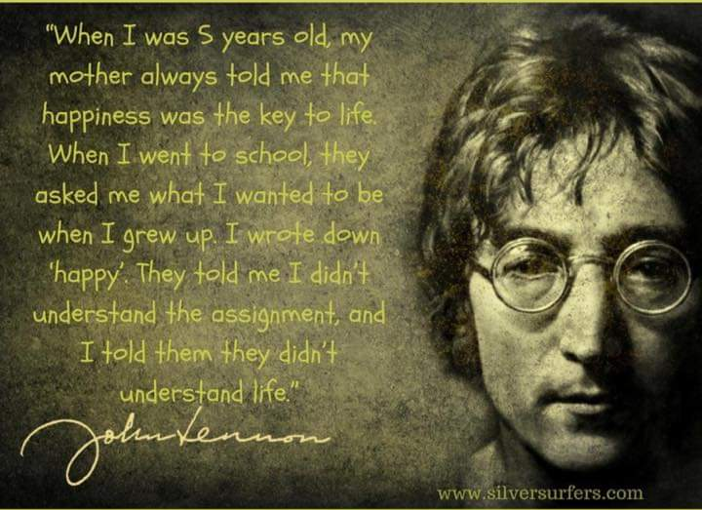

Answers to Riddles
- Day breaks and night falls
- The Match
- None
- Hospital
- None Coconut trees don’t grow Bananas

And finally some interesting old English Words.

Brabble - to argue loudly on matters of no importance
Crapulous - Feeling ill from eating or drinking too much
Fudgel - to give impression you are working hard when you are not
Hugger-Mugger – Secretive and covert behaviour
Snollygoster - someone who has intelligence but no principals
Cockalorum - small man with a big opinion of himself...
Trumpery - Things that look good but are basically worthless (I said Things)
Snotter – someone who is wise
Quagswag – to shake something backwards and forwards
Mugwump - Somebody in charge who tries to be above petty squabbles and tries to be an angel of peace
Vinomadefied - not made by wine but dampened by it, once sufficiently dampened all manner of wonderful things happen
Bumferzzled – To be conned
Pettifogger – small minded individual usually an inadequate lawyer who squabbles over minor points and won’t let it go even when proven wrong

Now the challenge is how many can use them into a sentence.

Keep Safe everyone

