Friday Funnies 18th. December
I was at lunch with a friend the other day, when I pointed out two old men sitting across the room. That will be us in few years I said. He replied it is us stupid you’re looking at a mirror.
Husbands message
Honey I got hit by a car on my way home, Tina has brought me to hospital. I’ve had an Xray The blow to my head has caused concussion, I have broken my right leg and left arm plus a couple of ribs, but I’ll mend.
Wife’s response. Who’s Tina
How to start a fight.
Wife askes What’s on TV. Husband replies Dust.
My friend Joe recently went on a Dolly Parton Diet. Now he’s Joe Lean. Joe Lean. Joe Lean,

Lexicons
- England has no kidney bank, but it does have a Liverpool .
- Haunted French pancakes give me the crepes.
- This girl today said she recognized me from the Vegetarians Club, but I'd swear I've never met herbivore .
- I know a guy who's addicted to drinking brake fluid, but he says he can stop any time.
- A thief who stole a calendar got twelve months .
- When the smog lifts in Los Angeles, U.C.L.A.
- I got some batteries that were given out free of charge.
- A dentist and a manicurist married. They fought tooth and nail .
- A will is a dead giveaway.
- With her marriage, she got a new name and a dress.
- Police were summoned to a daycare center where a three-year-old was resisting a rest.

You can get your wife jewellery, an expensive purse or perfume, but she will never forget the Christmas you bought her a mop.

Man dies after falling into a Vat of coffee, his wife tells reporters he didn’t suffer it was instant.
At this point I’ve order that much online, if Hermes turns up with a Llama tomorrow it is what it is.
Oxymoron
An oxymoron is a phrase is two words with contradictory meaning brought together.
Clearly Misunderstood, Exact Estimate, Small Crowd, Pretty Ugly, Only Choice, Act Naturally, Found Missing, Fully Empty, Seriously Funny, Original Copies

I never thought I’d be the kind of person who would wake up every morning and exercise.
And I was right.
Husband says to wife. The post man has just told me has slept with every woman in the street but one.
Wife replies. I bet that it’s the stuck up woman at number 5.

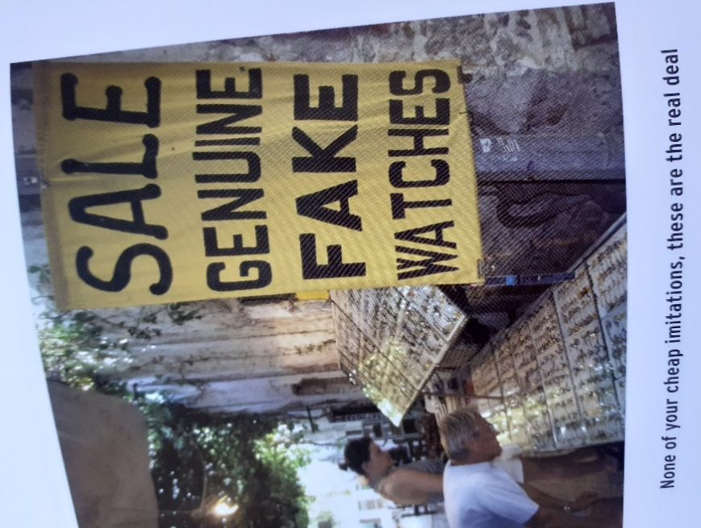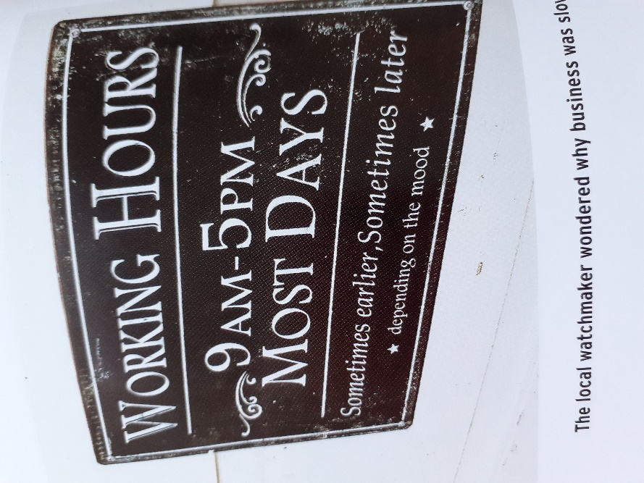
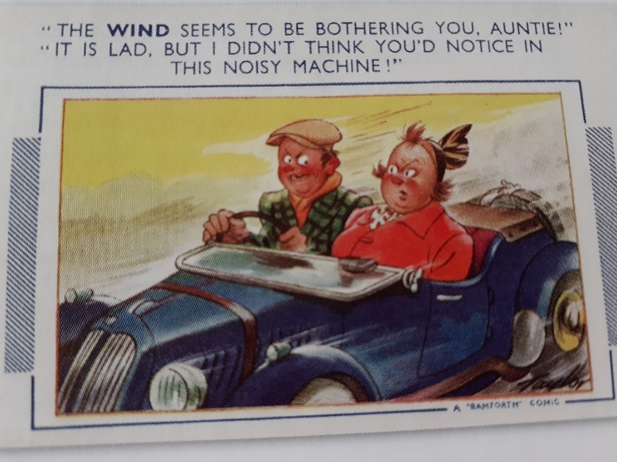

Paraprosdokians
A figure of speech with a surprising unexpected end, Loved by Winston Churchill.
- If I agreed with you we would both be wrong
- Since light travels faster than sound some people seem quite brite till you hear them spek.
- Knowledge is knowing that a Tomato is fruit, wisdom is knowing not to put it in a fruit salad.
- I didn’t say it was your fault I said I was blaming you.
- A clear conscience is the sign of a bad memory.

Merry Christmas to you all.
See you next year.
That’s all folks

Michael

