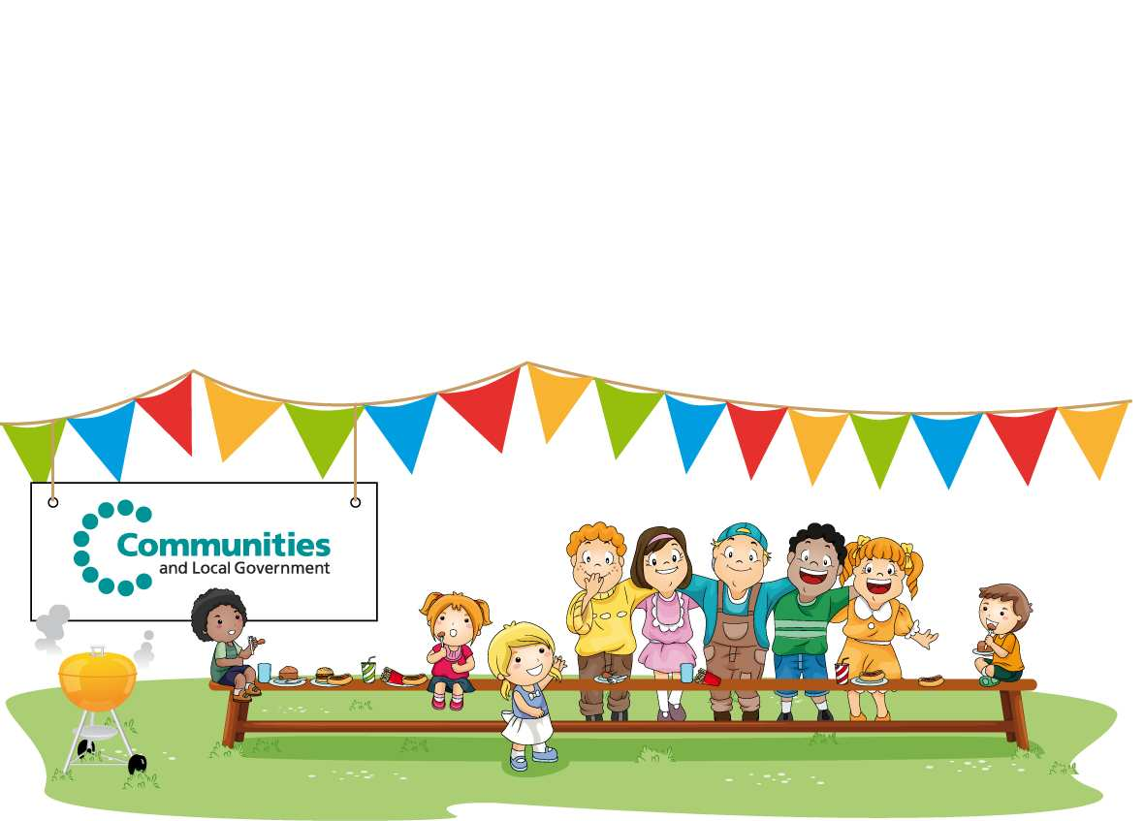
Your guide to organising a street party or fete

Foreword by Eric Pickles
Secretary of State for Communities and Local Government

Street parties and fetes are a traditional part of community life; they are a simple way for us to get to know our neighbours and meet members of our community. We want to make it easier for you to hold these sorts of local events, without having to plough through mountains of forms and red tape. So we have produced this simple step by step guide to how to hold a community event in your local area. It includes one simple form for you to use to let your local authority know about your plans, so you can get on with the real work of organising a fun event.
Good luck.

What sort of events does this apply to?
This is about the sort of street parties and fetes that groups of residents get together to arrange for their neighbours. The main differences between a small street party and fetes and larger public events are listed below:

Street parties and fetes:
For residents/neighbours only Publicity only to residents
No licences normally necessary if
music incidental and no selling is involved No formal risk assessment needed
Self-organised
Larger public events: Anyone can attend
External publicity (such as in newspapers) Licence usually needed
Insurance needed
Risk assessment common
Professional/skilled organisers

Organising small, private street parties and fetes is very simple and generally does not include activities that need a licence, such as selling alcohol or providing certain types of entertainment. If you want to have a pay bar or intend to provide entertainment to the wider public, or charge to raise money for your event, you will need a Temporary Event Notice which is a type of temporary licence and costs £21. Similarly, larger public events attracting more people will require a different process. If you need a Temporary Events Notice or would like to hold a larger public event, please contact your council for further information and advice.
It’s that simple

If you would like to hold a street party or fete, you can use the form below to let your council know about your plans. Alternatively you could go to your council’s website to see if they have their own form.
The number one tip for holding a party is to plan early, think about what you want to achieve and get in touch with your council at least 4-6 weeks in advance. A good first point of contact will be your council’s events or communities team.
More helpful tips, advice and support for organising a successful event can be found on the Streets Alive website www.streetparty.org.uk and The Big Lunch website www.thebiglunch.com. Do check them out, they’re great.

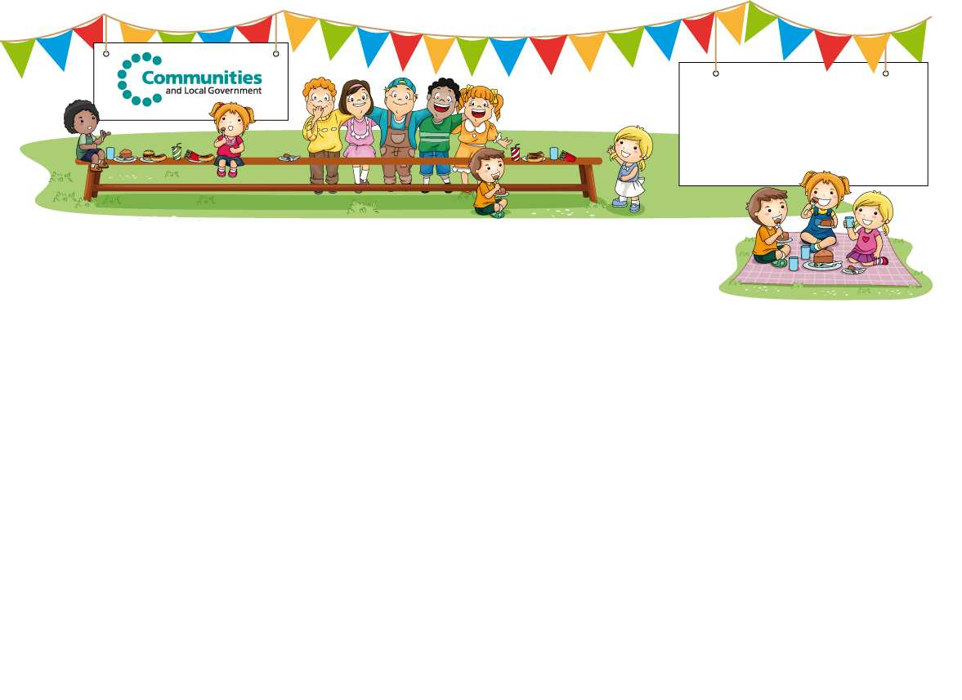
Celebrating your community Application form for a street party or a small community event
From: To:

Road closure for residential or neighbourhood street parties

Name of person:

Organisation (if applicable):

Contact address (incl. postcode):

Telephone number (daytime):

Telephone number (evening):

Email address:

Name of road(s) to be closed:

Date and time of road closure

If you plan to close only a section of the road(s), where will the closure begin and end?

Give a brief list of properties affected. This means any property, residential or commercial, which is located on or accessed only by the road(s) you wish to close – e.g. Cedar Close numbers 1-20 and numbers 21-98

Are any of the roads to be closed used by through traffic? YES/NO?

If yes, you will need to send a traffic plan showing the exact extent of the closure and an alternative route for traffic.
Are you planning on closing a road that is part of a bus route? YES/NO?

If yes, you will need to consult the bus company and attach a copy of their response.

Will access for emergency vehicles (if required) be readily available at all times? YES/NO?

If no, you will need to discuss this with your council and emergency services. In the interest of safety we highly recommend that roads are accessible for all emergency vehicles.

How will people know the road has been closed off - have you thought about barriers/diversion signs needed?

If yes, can you say what you will be doing?

If no, you can speak to your council or Streets Alive (www.streetparty.org.uk) who will be able to help you with street signs.
Have most residents agreed to this neighbourhood/community event? YES/NO?

The council will want to ensure most people are happy with this event, so if there are any objections you should let them know. They may be able to help you resolve any objections. It is worth remembering that not everyone will be able to participate so let everyone know what time the party will start and end (you may want to finish by 9pm to minimise noise).

If you are planning a road closure you will also need to consult businesses in the wider area that may be affected. Have you already consulted about the road closure?
YES/NO?

If yes, please attach a copy of your consultation invitation/notice and confirm the date it was sent:

What happens next?

Send your form to your local council (in a two-tier authority this will be the borough or district council).

The council will look at what you are proposing, will process your application for road closure and will let you know if there is anything else you need to consider.

We hope this guidance has made things easier for you. Good luck with your event.

FAQS and checklist

Q. Do we need insurance cover?

A. Most local authorities do not ask for public liability insurance cover for a small residential street party. But where you or your council think insurance would be a good idea you might find it helpful to go on Streets Alive (www.streetparty.org.uk) and The Big Lunch website (www.thebiglunch.com) for further advice. Quotes for insurance start from as little as £50. The costs can always be split between residents, or you could hold a raffle or ask for donations to cover the costs.

Q. Do I need to do a risk assessment?

A. Most local authorities do not ask for a risk plan for small street parties, but you may wish to think about how you can minimise things going wrong and have a back up plan, for example - what would you do if there was bad weather? Can you use plastic plates and cups rather than glass? Have you made sure an adult is in charge of the barbeque etc.

Q. We're serving alcoholic drinks - do we need an alcohol licence?

A. No, licences are only required if alcohol is sold. At a private party, sharing drinks with your neighbours does not require a licence. If you did want to sell alcohol, you will need to contact your council for a Temporary Events Notice form. This form costs £21.

Q. We're playing music - do we need an entertainment licence?

A. No - if your street party is a private party for residents and the music is not advertised in advance to attract people, and you’re not making money then there is no need for a licence for your music, whether it’s live or recorded.

Q. Do we need a permit to serve food?

A. No - as a private party, you do not need a licence under the Licensing Act 2003 to sell food (unless you wanted to only sell hot food and drink after 11pm). Remember you can always ask your neighbours to bake a cake, make a sandwich or bring food to share with one another. This is also a good way to bring different groups of people together.

Q. We’re having a tombola/raffle - do we need permission?

A. Probably not. If the tombola/raffle tickets are sold on the day and the prizes are not worth more than £500 in total then it will be exempt from gambling regulations (however, if tickets are sold in advance of the event, you will need a lottery registration but do speak to your council first). Any proceeds from the tombola/raffle must go to a good cause such as charity or even covering the cost of your party. Alternatively, if you did want to raise some money for your local church or charity, you can always ask people for donations.

Q. Do we need to clean up afterwards?

A. Yes, you will need to clean up after your street party. It’s your street, your party, so keep your local area clean and tidy. Let people know in advance what time the party will finish and have a section set aside for bin bags and recycling.

