S | T | O | R | E | D | A | D | M | I | R | A | L | I | P | H | Y | U | N | M | A | L | X | F | B
A | M | B | H | J | K | M | L | P | Q | U | E | S | E | E | T | I | H | W | L | L | A | M | S | K
T | E | A | T | I | M | E | A | T | H | O | N | A | C | B | X | Z | W | V | T | H | R | E | R | S
H | A | G | L | Y | H | N | M | K | L | W | C | D | W | Q | U | T | A | V | C | W | I | E | C | M
O | D | E | U | L | B | N | O | M | M | O | C | H | A | E | V | W | L | X | V | N | M | Z | Q | A
B | O | R | F | B | T | T | H | N | C | V | M | E | R | B | Q | U | L | B | V | X | D | Z | M | L
S | W | B | G | H | N | O | S | K | I | P | M | V | A | X | D | Q | B | Y | U | M | A | U | I | L
T | B | E | R | C | P | U | R | P | L | E | H | A | I | R | S | T | R | E | A | K | E | C | D | C
E | R | W | E | I | B | N | M | T | E | R | T | Q | R | G | H | B | O | G | H | R | T | Y | U | O
L | O | V | E | R | M | F | A | P | O | Q | U | R | B | B | N | M | W | R | T | W | I | Y | T | P
G | W | E | S | T | W | S | I | F | G | I | O | Y | H | K | L | I | N | K | M | A | H | C | V | P
N | N | D | F | Z | C | T | T | X | W | R | S | T | Y | U | N | E | M | N | T | R | W | H | A | E
I | F | S | C | V | E | R | Y | O | E | M | W | E | L | C | O | N | D | E | S | P | W | I | N | R
R | E | D | V | G | Z | Q | N | P | N | R | D | F | S | W | R | F | N | W | J | K | N | A | C | K
E | F | C | N | B | N | K | M | L | O | E | Q | U | W | H | S | X | V | B | H | T | W | E | R | F
S | T | A | G | A | T | E | K | E | E | P | E | R | S | E | E | U | Q | E | E | I | V | N | M | T
W | R | E | T | C | E | T | R | W | Q | C | V | B | N | M | K | L | G | D | L | J | T | I | R | F
O | C | H | A | L | K | H | I | L | L | B | L | U | E | V | Q | S | L | R | Z | V | B | E | N | M
C | O | P | P | S | F | W | T | Y | H | I | L | L | B | L | U | A | Q | U | A | S | T | W | C | V
X | E | R | D | R | T | A | M | M | O | C | O | M | M | Z | D | C | V | B | N | N | O | W | D | B
E | U | L | B | R | U | T | B | Y | Q | H | O | L | L | Y | B | L | U | E | D | E | W | B | M | Y
P | R | I | N | C | E | R | U | P | E | R | T | W | I | N | G | S | A | B | O | V | E | O | U | E
D | R | T | X | R | E | P | P | I | K | S | Y | G | N | I | D | Z | R | V | Y | U | I | O | R | N
R | E | D | P | E | A | C | K | W | H | I | T | E | L | A | D | V | E | R | Y | D | U | N | Y | B
S | I | L | V | E | R | W | A | S | H | E | D | F | R | I | T | I | L | L | A | R | Y | O | U | R

BRITISH BUTTERFLIES
PEACOCK, SMALL TORTOISESHELL, PAINTED LADY, COMMA, RED ADMIRAL, PURPLE EMPEROR,
WHITE ADMIRAL, SILVERWASHED FRITILLARY,
GATE KEEPER, MEADOW BROWN, RINGLET,
WALL BROWN, ORANGETIP, MARBLED WHITE,
SMALL WHITE, BRIMSTONE, SMALL COPPER,
BROWN ARGUS, CHALKHILL BLUE, HOLLY BLUE,
PURPLE HAIRSTREAK, DINGY SKIPPER, COMMON BLUE

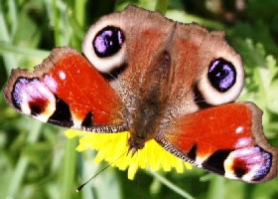Peacock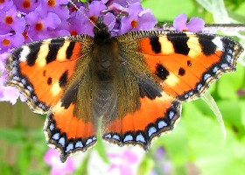Small Tortoiseshell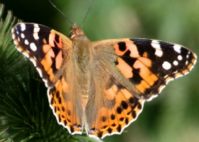Painted Lady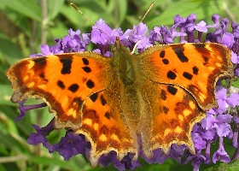Comma
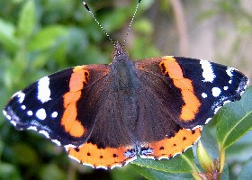Red Admiral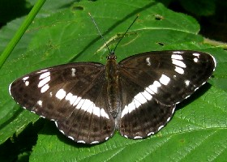White Admiral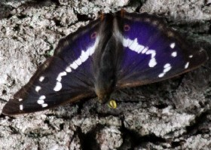Purple Emperor

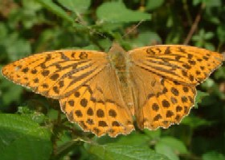Silver-washed Fritillary m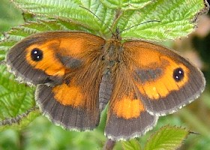Gatekeeper (m)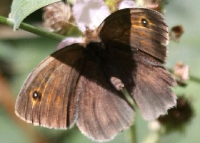Meadow Brown (m)
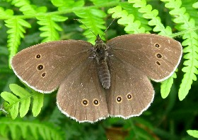Ringlet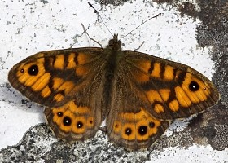Wall Brown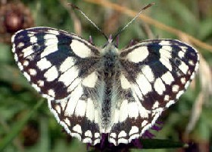Marbled White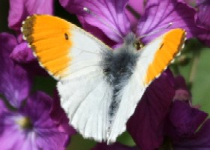Orange Tip (m)

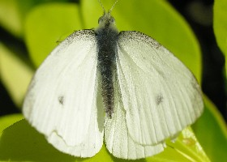Small White (m)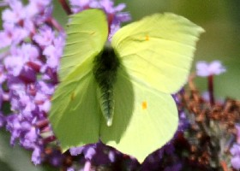Brimstone (m)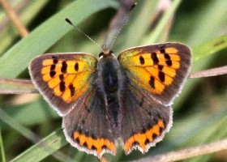Small Copper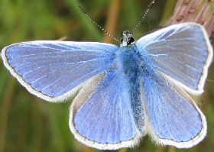Common Blue (m)
)
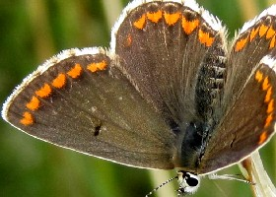Brown Argus (f))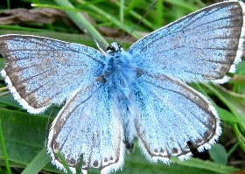Chalkhill Blue (m))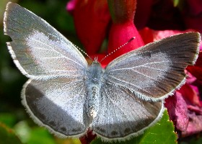Holly Blue (f)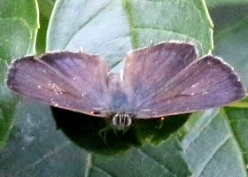Purple Hairstreak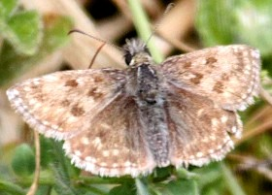Dingy Skipper

