BLYTH TOWN COUNCIL

PRINCIPAL OFFICER

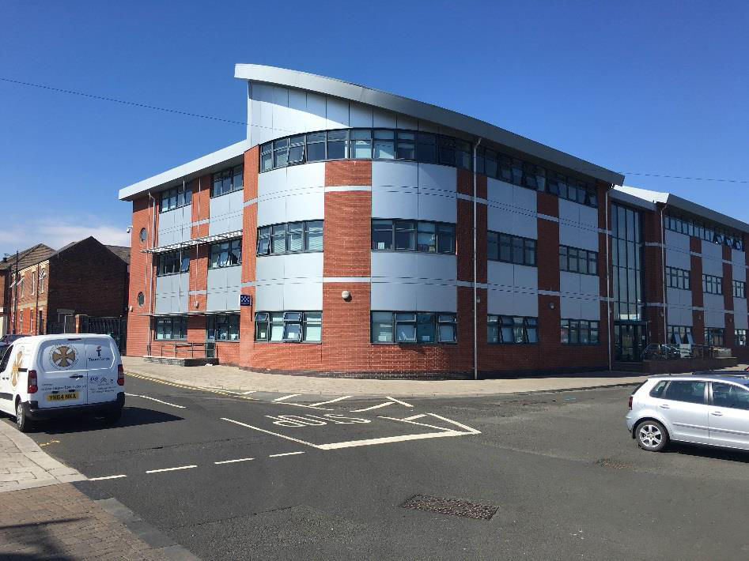
Candidate Information Pack

BLYTH TOWN COUNCIL

The town of Blyth is situated in the southeast of the scenic County of Northumberland and is its largest town with a population of 40,000. The Town Council was established following the Local Government Review which provided for a single unitary authority in Northumberland.

The Town Centre is currently being energised in partnership with the County Council and exciting projects are being developed including a cultural centre on the redeveloped marketplace. In addition, works are being carried out on the gateways to the town as well as other projects that can be seen on the plan below.

This an exciting, once in a lifetime opportunity, to be involved in the future of the Town and the various projects underway. For further information see the project map below.

The Town Council is one of the largest top 30 community councils in the UK and has a budget of £1.4m. The Town has a Partnership Agreement with the County Council to deliver an enhanced service costing about £350,000 in addition to the basic core service delivered throughout the whole county. This Partnership Agreement is currently under review. The Council delivers several services including the management of allotments, responsibility for play areas, litter bins and bus shelters and has developed its own services in the areas of community grants and the significant promotion of events. The Town Council is also engaged in developing a Neighbourhood Plan that it hopes to have approved around April 2024.

The Town Council has decided because of the developing level of services to add a full-time post of Principal Officer to augment the present staff and develop and improve current and new services. This is an ideal opportunity to gain experience in a vibrant community Council and help shape the Town. The post is seen as a potential stepping stone in the hierarchy and an opportunity to move up to Deputy Town Clerk and ultimately Town Clerk, on their retirement. All reasonable assistance will be given to the successful candidate for career development.

This is an exciting opportunity for an able and energetic person with many worthwhile challenges ahead and the possibility of future promotion in the organisation for the right candidate.

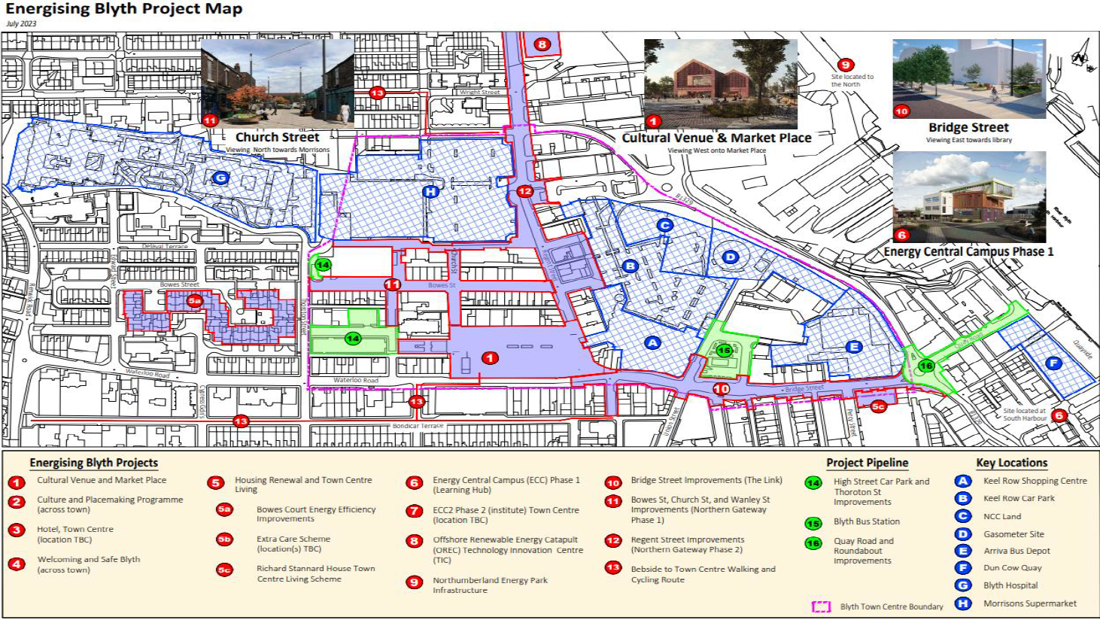

Links
https://www.blythtowncouncil.org.uk/neighbourhoodplan.php
https://www.northumberland.gov.uk/Economy-Regeneration/Programmes/Town-Centre-Regeneration/Energising-Blyth/Investment-Plan.aspx

BLYTH TOWN COUNCIL

PRINCIPAL OFFICER

MAIN TERMS AND CONDITIONS

1. SALARY

The full-time equivalent salary will be £45441-£49498 on Scale LC3- substantial benchmark range- points 37-41 as evaluated within the salary scales of the National Association of Local Councils and the Society of Local Council.

2. PLACE OF WORK

Arms Evertyne House, Quay Road, Blyth, Northumberland. NE24 2AS

3. HOURS OF WORK

Full time, 5 days per week (37 hours)

4. HOLIDAYS

26 days rising to 31 days (pro rata) after 5 years continuous service, plus 2 statutory days and public holidays. (3 days to be used over the Christmas period to allow office closure).

5. PERIOD OF NOTICE

4 weeks written notice is required on either side to terminate the employment.

6. PROBATION PERIOD

The successful applicant will be subject to a six-month probationary period which will involve regular discussions on progress.

BLYTH TOWN COUNCIL

PRINCIPAL OFFICER

JOB DESCRIPTION

Overall Responsibilities
The Principal Assistant will assist the Proper Officer and Responsible Finance Officer of the Council (Town Clerk), and Deputy Town Clerk in undertaking their duties, and be responsible for carrying out the instructions of the Council.
The Principal Assistant is expected to assist in formulating overall policy as well as research/produce information that will assist members in making informed decisions as well as the operation of the office.
The Principal will oversee the governance and probity arrangements of the accounting function of the Council and assist in the strategic financial management to ensure high standards.
Specific Responsibilities
Strategic Responsibilities
- To assist the Town Clerk and Deputy Town Clerk in developing and implementing strategic vision for the Town and develop appropriate performance management arrangements to monitor their achievement.

- To help monitor the implemented policies of the Council to ensure their effectiveness and propose modifications as appropriate.

- To assist the organisational structure to meet the needs of the Town Council including identifying suitable training for staff to meet their responsibilities by playing a supportive and coordinating role to ensure the priorities and objectives of the Council are achieved.

Statutory Responsibilities

- To assist in meeting the legal, statutory, and other provisions governing or affecting the running of the Council.

- To assist Members of the Council to changes in respect of their statutory and other responsibilities.

Financial Responsibilities

- To assist in the preparation and accuracy of the Council’s accounts and preparation of records for audit purposes and VAT.

- To oversee the financial transactions of the Town Council and to introduce checks to enhance governance arrangements.

- To assist in developing an improvement programme to ensure financial and other efficiencies are identified, reviewed and amended, ensuring value for money.

- To assist in carrying out independent financial/other checks which will form part of a continuous audit of the Council’s financial records are carried out to prevent/reduce any error, fraud or abuse of public funds.

Administrative Responsibilities

- To help ensure that the Council’s standing orders, financial regulations and delegated schemes are regularly reviewed and to ensure that any changes required by changes in the law, guidance or best practice are implemented.

- To contribute to the efficient running of the Town Council offices by reviewing and monitoring systems, processes and procedures and update where appropriate, making best use of information technology.

- To assist in the general running of the Town Council in relation to correspondence and preparation for meetings.

- In the absence of the Town Clerk and Deputy Clerk, ensure the Council runs effectively and to maintain effective contact with Members where necessary.

- Prepare a plan for a continuous review of all processes, and the delivery / improvement within agreed timescales.

- To assist the Town Clerk/Deputy Town Clerk on any work issue that they require to be carried out.

- To attend meetings of the Council and meetings of its Committees.

Staff Responsibilities

- To supervise and manage other members of staff in keeping with the policies of the Council and to undertake all necessary activities in connection with performance management.

- To maintain any delegation and allocation of responsibilities that have been agreed by the Town Clerk for members of staff.

- To assist in identifying the appropriate training of staff and updating of skills to match their responsibilities and duties, in light of annual appraisals and/or personal development plans that have been carried out by the Town Clerk.

Other Responsibilities

- To act as a representative of the Council as required, in the absence of the Town Clerk and Deputy Town Clerk, including attending meetings with key stakeholders and positively promoting the Council within the local community to ensure its continued presence in local affairs.

- To process and respond to freedom of information (FOI) requests in a professional manner ensuring Council approval, where appropriate, before information is released.

- To attend training courses on the work and role of the Clerk/Deputy Clerk, as required by the Council.

- To undertake specific projects from time to time at the request of the Town Clerk/Council.

- Develop a communications/ public relations strategy and review, improve, and monitor communications which includes and having more of a day-to-day involvement with our website/social media.

- Assist in the office where demand/expectations have increased e.g., partnership work, community grant performance visits, neighbourhood planning and other areas.

- To undertake such other responsibilities and functions as may be required from time to time by the Council, commensurate with the duties and responsibilities of the post.

- The job description is subject to review and may change over time to meet the needs of the organisation. Any changes will be subject to consultation with the postholder.

PERSON SPECIFICATION

NOT REVIEWED YET

Factor | Essential | Desirable
Education and Qualifications | • Educated to Degree level or equivalent  • A relevant professional qualification where appropriate | • Recognised Business, Finance or Administrative qualification  • Certificate in Local Council Administration
Skills and knowledge | • Good written and verbal communication skills  • Leadership skills  • Strong analytical skills  • General administration and presentation skills  • Numerate and able to spot errors • Proficient in the use and  maintenance of manual and computer information systems  • Ability to collate and analyse information and distribute to a range of audiences in appropriate form  • Able to write clear, concise reports and minutes  • Ability to build effective working relationships with members of the Council, staff and a range of stakeholders | • Theoretical and/or practical knowledge of the statutory duties of a local Council  • Practical experience of local government financial procedures  • Knowledge of current employment and health and safety legislation

Experience | • Financial Monitoring and Control • Delivery of agreed corporate  objectives  • Leading a team, inspiring and empowering colleagues  • Managing and developing staff  • Experience of financial/personnel systems and procedures  • Previous experience of change management and organisational redesign  • Managing a range of activities to deadlines within pre-agreed timescales within changing priorities  • Procurement of resources and services within a predetermined budget  • Development and maintenance of admin procedures  • Previous experience of planning, development and leading on complex projects  • Developing solutions to a range of practical and technical problems  • Experience of creating and manipulating spreadsheets  • Fully competent in using Microsoft Office | • Experience of a leadership role in a complex organisation  • Local Government experience • Committee experience

Personal Qualities | • Strong interpersonal, negotiating, and mediating skills  • Handles problems confidently and positively  • Ability to establish good customer relationships  • Methodical and accurate approach  • Ability to prioritise and work on own initiative and complete tasks without supervision  • Honest, integrity and trustworthy
Special Requirements | • Flexibility to attend evening meetings and to work at any Council site as deemed necessary  • Commitment to continuing professional development

